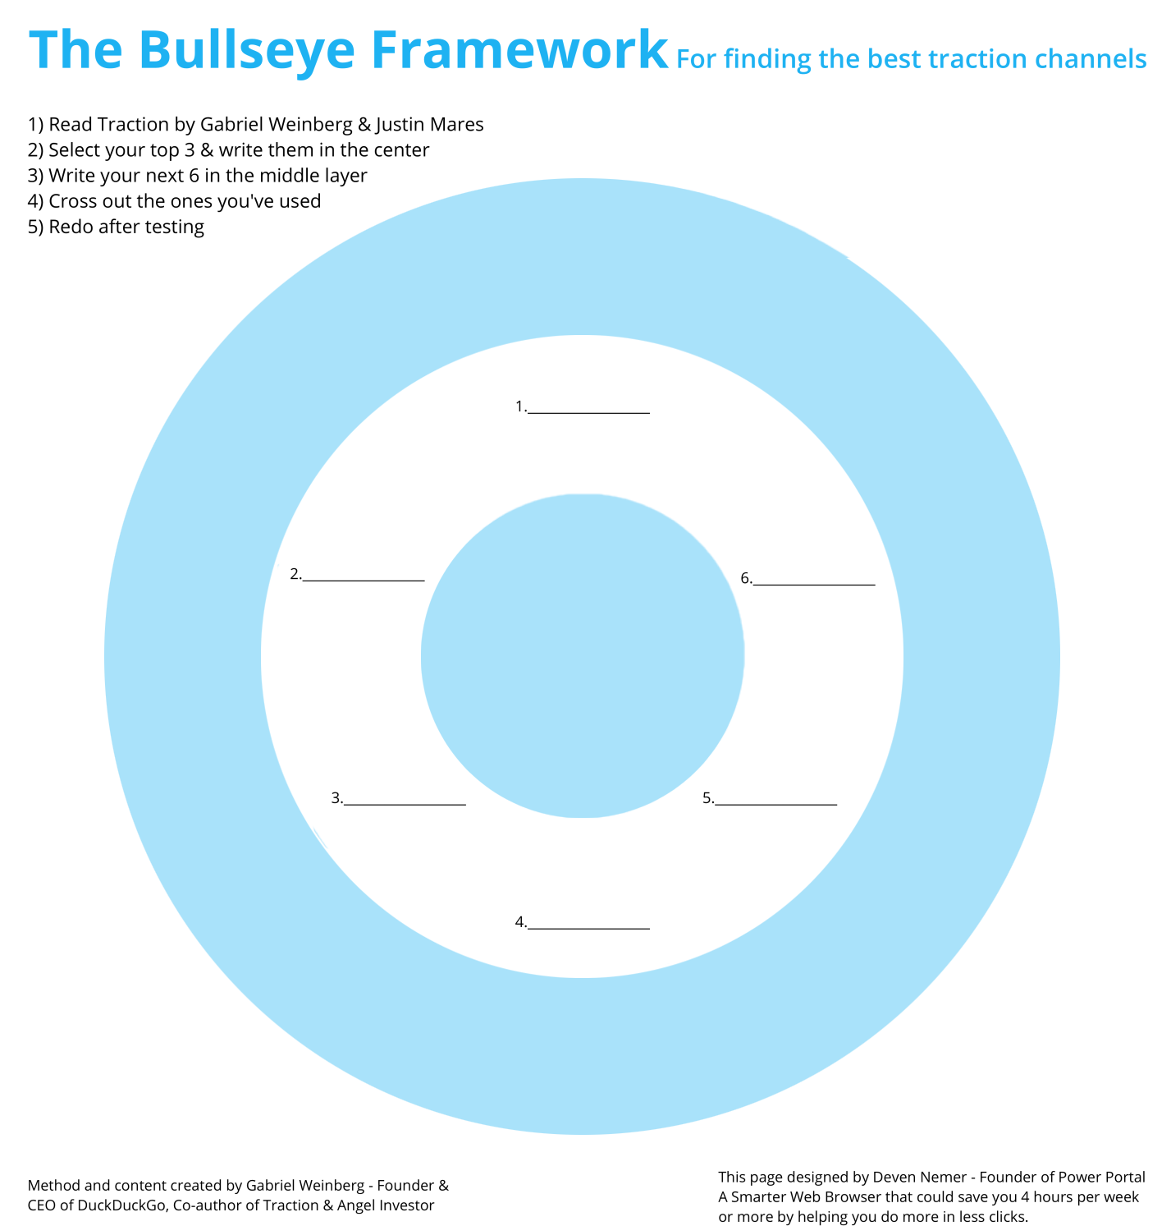

Affiliate Programs

Viral Marketing/Social Media Search Engine Opt.(SEO)

Online PR Existing Platforms

Email Marketing Offline Events

Networking Offline Ads

Public Relations Warm calling

Unconventional PR Trade Shows

Social and Display Ads Speaking Engagements

Content Marketing Community Connections

Promotions Sales

1.

4.

5.

3.

6.

2.

3. Social media

2. Community connections

1.Speaking

**Notes:**